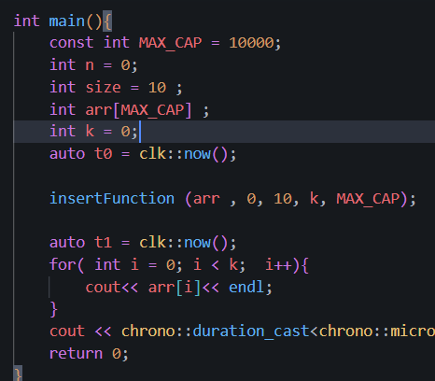
1A. Insert into empty arrays

Case1 | microsecound
10 | 0

1B. Insert when no full , no index given.

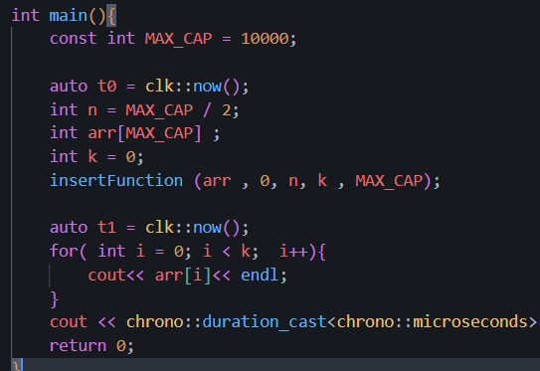
test | time
case | 0ms

1C Insert when not full , no index given.
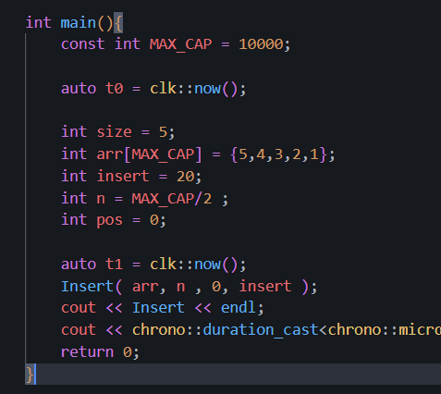
+ Insert at front of index
test | time
case | 0

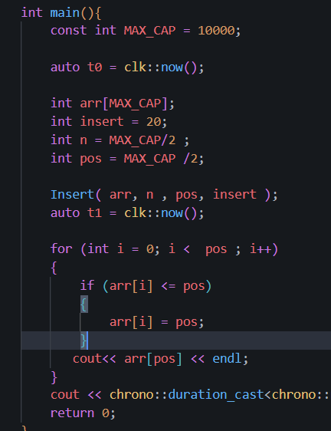
+ Insert at Middile of index

test | time
case | 20
+ insert at end element
test | time
case | 20
